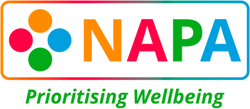
In partnership with

Afternoon Tea "Showstopper" Cakes!

How to enter: Please complete the information below and email it to gianna@napa-activities.co.uk
Email Address:

Name:

Care Service Name and Organisation (if applicable):

Are you a NAPA Member?

How did you hear about this competition?

How did you involve the individuals you support and the catering team with the planning and creation of the showstopper?

Email Address:
Name:
Care Service Name and Organisation (if applicable):
Are you a NAPA Member?
How did you hear about this competition?
How did catering and activities teams work together to plan and create your showstopper, and involve the individuals you both support?

Do you consent to NAPA and Lakeland Dairies using your entry write-up for marketing purposes?
*This could be used by NAPA, Lakeland Dairies or an external media organisations.

Yes/No (delete as appropriate)

EMAIL YOUR ENTRY TO GIANNA@NAPA-ACTIVITIES.CO.UK

All care services are invited to enter, closing date is Monday 21st August 2023

*TERMS AND CONDITIONS APPLY - CLICK HERE

